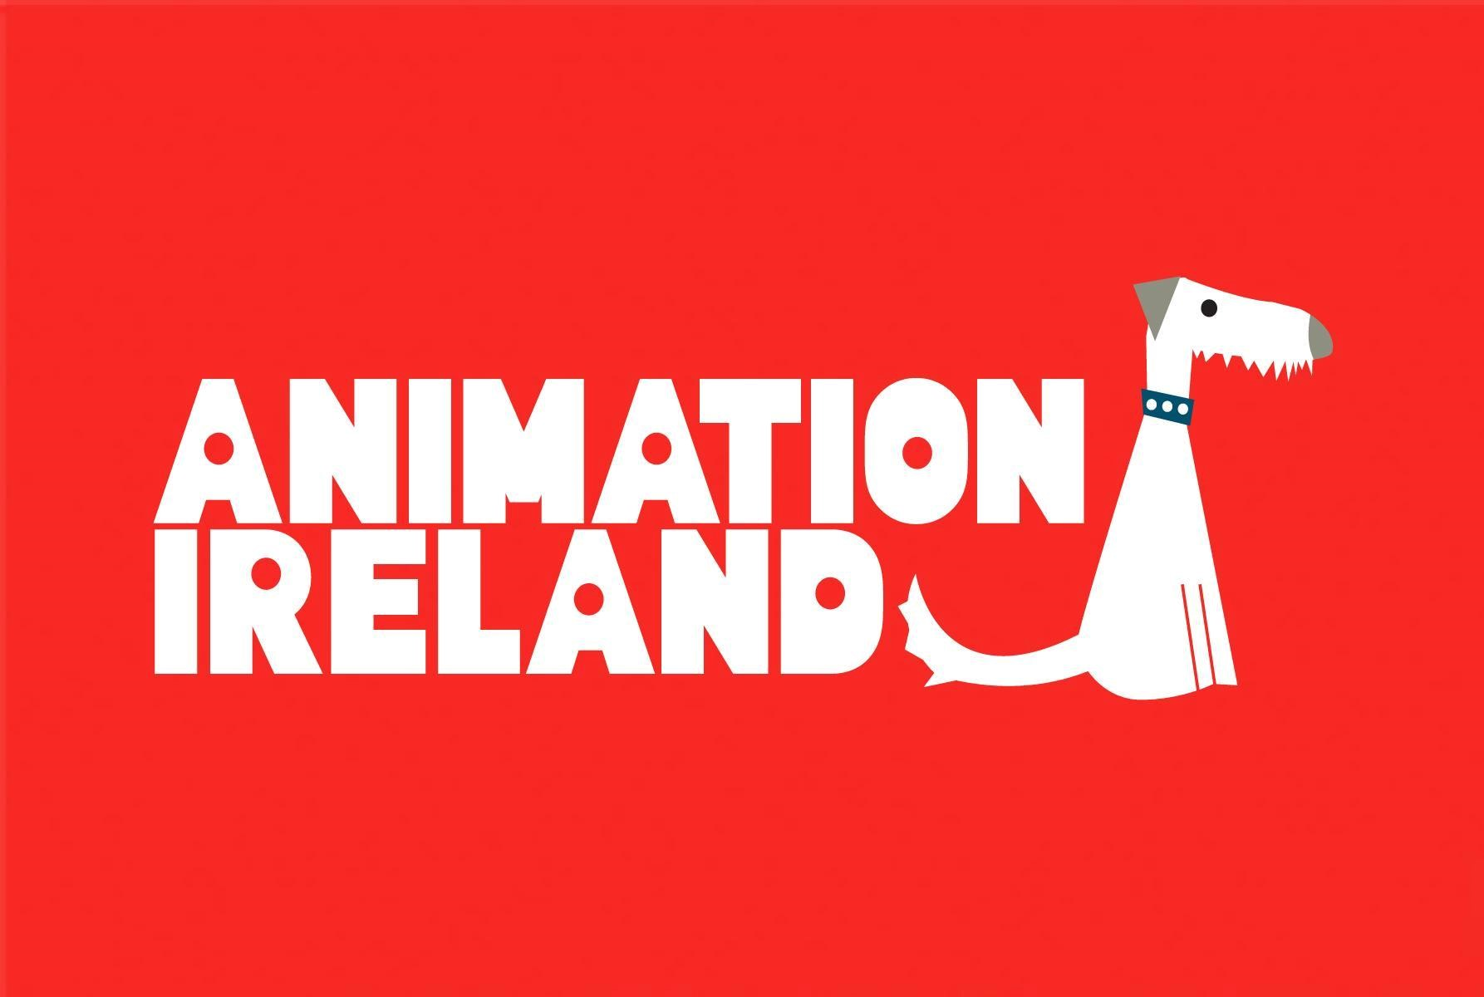

Animation Ireland Artificial Intelligence Policy

Statement & activities page 1
Animation Ireland internal policy & members policy page 2
External applicants, suppliers & stakeholders policy and Accountability page 3
Recommendations page 4
Additional Information and Resources page 5
Risks associated with AI tools page 6

Statement

Animation Ireland is dedicated to promoting technology use in a manner that puts human creativity front and centre of the animation process.

Animation Ireland has established a working group to develop a framework of ethical principles and guidance to assist members to adhere to international standards and regulatory requirements.

Animation Ireland recommends that Artificial Intelligence systems are developed and deployed under a robust framework of ethical principles, including sustainability, transparency, fairness, accountability, and data privacy.

Animation Ireland will continuously engage with stakeholders to refine our principles and guidance and welcomes constructive feedback to drive continuous improvement.

Activities

Animation Ireland represents a diversity of companies and working practice across pipelines including but not limited to television production, film production, immersive and XR, games development, interactive media, programming and more.

Animation Ireland’s activities fall under the following categories:

- Lobbying and advocacy for the Irish Animation sector
- Representation of member studios in the public space
- Administration of funding
- Management of the National Talent Academy for Animation
- Organisational activities
- The Irish Animation Awards

Policies

1. Animation Ireland internal policy

Within Animation Ireland, the National Talent Academy for Animation and the Irish Animation Awards, our team and administrators commit to transparency and accountability around the use of AI.

We do not permit the use of generative AI in any of our internal activities (emails, reports, funding applications, speech recognition and transcription for meetings, etc.).

We do not allow the use of AI in the selection / short-listing (high risk due to inherent bias) / transcribing / subtitling as Gaeilge, etc. of projects submitted to the National Talent Academy for Animation and to the Irish Animation Awards.

2. Members policy

Animation Ireland recommends that member studios have an internal AI Policy.

Member studios are encouraged to familiarise themselves with the EU AI Act.

Members studios are expected to understand common risks associated with AI use (for example, use of AI technology in hiring and recruitment without strict human oversight).

Member studios are responsible for ensuring that end consumers are made aware of the use of AI, and that teams working in a studio environment are fully aware of AI usage in the pipeline.

Use of generative AI to create final published work, (e.g. promotional art, music, voiceover, etc.) should be publicly stated in end credits or subtitle for video, or image caption for stills.

Animation Ireland member studios must maintain compliance with the Data Protection Act 2018 and Employment legislation.

We acknowledge that member studios might have limited control and oversight when outsourcing work to other organisations. However, we expect good governance from our members in sourcing and contracting vendors/suppliers.

Animation Ireland member studios are required to disclose use of generative AI within their work in the following instances:

- applying for membership or Animation Ireland membership renewal
- submitting videos for the Animation Ireland Showreel
- submitting images for the Animation Ireland repository
- submitting projects for any of the funds managed by Animation Ireland and the National Talent Academy for Animation
- submitting works for the Irish Animation Awards

3. External applicants, suppliers & stakeholders policy

Animation Ireland acts as an administrator for projects and funding schemes such as:

- Screen Ireland’s Innovation in Storytelling Fund
- Screen Ireland’s National Talent Academy for Animation
- Coimisiún na Meán’s Sectoral Learning and Development Programme (in partnership with Cultural & Creative Industries Skillnet)
- Networking events and Ireland stand at industry events (Screen Ireland, RTE, Enterprise Ireland, Northern Ireland Screen, etc.)

Animation Ireland must ensure compliance with the funders’ own AI policy regarding the use of AI in the development and delivery of these projects and funding schemes.

Members, organisations, companies and individual applicants are required to ensure that any outsource or supplier companies are also compliant with both the AI policies of the funder(s) and of Animation Ireland.

Applicants are required to disclose use of generative AI within their work and submissions:

- How it is used
- Why it is used
- What type is used
- Where and how the data is stored.

Accountability

This policy was created on 25th June 2025 by Animation Ireland’s AI Subcommittee, chaired by Ronan McCabe. It was last updated on 14th July 2025. Due to the pace of emerging developments in this area, we will review and update this document regularly. It will be renewed on or by 5th January 2026.

Questions or comments on this document can be directed to delphine.coudray@animationireland.com for attention of Delphine Coudray.

Recommendations

Animation Ireland recommends that member studios should keep a regularly updated policy on AI use which should be published and made available for stakeholders, employees, clients and freelancers.

To develop an AI Use Policy, we recommend that studios first follow a process of gathering and disclosing information to all stakeholders. Monitoring and understanding use cases of AI implementation allows stakeholders to make informed decisions.

It is recommended that studios:

- Appoint a Data Manager to oversee the use of AI in the organisation.
- Undertake and provide training for staff/crews relating to AI use and legal requirements
- Involve diverse stakeholders (artists, legal, tech) to spot biases or ethical issues in policy and procedures.
- Research and understand the risks associated with use of AI tools and their impact on Data Privacy, Non-Disclosure and Confidentiality agreements and policies.
- Document activities and use of AI relating to the organisation.
- Create a list of organisational and production activities that currently use or interact with AI, listing the scope and purpose of AI in each activity.
- Assess risks of each use scenario and create categories such as “accepted”, “approval required” or “not accepted”. The Data Manager is responsible for monitoring, approving or disapproving use of AI within the organisation.
- Clear contractual clauses to precisely define ownership, authorship, revenue, fair use and moral rights obligations. If a human artist is working on AI-generated material, they should be made aware.
- Ensure that human oversight and intervention is available throughout the process for all accepted use of AI. Always plan a human fallback if use of an AI tool threatens the rights or ethics of the organisation and its stakeholders. Work generated or assisted by AI should be reviewed by humans.
- Continue to monitor regulatory trends. Follow Irish AI Advisory Council announcements, EU directives, and national legislation changes.
- Clearly inform users or audiences when content is AI-generated. Consider disclaimers or labels indicating when work is AI-generated.

Additional Information and Resources

Ireland’s AI Advisory Council
https://www.gov.ie/en/department-of-enterprise-tourism-and-employment/campaigns/artificial -intelligence-ai-advisory-council/
https://www.gov.ie/en/department-of-enterprise-tourism-and-employment/campaigns/artificial -intelligence-ai-advisory-council/

A High-Level Summary on the EU AI Act
https://artificialintelligenceact.eu/high-level-summary/

Ireland’s National AI Strategy (Refresh 2024)
https://enterprise.gov.ie/en/publications/national-ai-strategy-refresh-2024.html#:~:text=Irelan d's%20first%20National%20Artificial%20Intelligence,and%20for%20delivering%20public%2 0services

Training by the Law Society of Ireland: https://www.lawsociety.ie/productdetails?pid=3645

Fís Éireann/Screen Ireland

CnaM

RTÉ

Not By AI https://notbyai.fyi/

Members may want to consider adding a certification badge to identify where work is created without AI.

The Not By AI badges are created to encourage more humans to produce original content and help audiences identify human-generated content.

RISKS ASSOCIATED WITH AI TOOLS

Member studios should be aware of the risks associated with AI tools.

Generative AI systems often train on massive datasets that include copyrighted materials (art, music, literature, etc.) without explicit permission from creators. This has led to the following negative effects for the creative space:

- Copyright Infringement & Legal Disputes
- Processes run off-site - Models and Results can change overnight
- Job Displacement
- Loss of Authenticity
- Bias & Misrepresentation
- Devaluation of Art
- Dilution of Artistic Style
- Loss of Quality
- Plagiarism & Ethical Concerns
- Increased Carbon Emissions

Programming or published works created using Image, Text and Video Generation AI tools are not eligible to claim authorship or copyright protection.

Use of third-party text summary, translation and grammar correction tools like ChatGPT, Google Translate and Grammarly may violate an organisation’s commitment to Confidentiality, Non-Disclosure and Data Privacy.

Examples of potential applications using AI:

Image generation and manipulation

- Inbetweening
- Design/concept artwork
- Recolouring
- Colour correction
- Background replacement
- Logo generation and font-to-vector tools
- Asset creation

Video generation

- Video creation
- Editing and compiling

Audio generation and analysis

- Speech recognition and transcription
- Music composition
- Voice cloning
- Voice captioning and overdubbing
- Auto lip-sync
Text generation and analysis

- Script analysis
- Language translation
- Scriptwriting
- Script editing
- Automated Captioning and Subtitling
- Font replacement

3D and VFX

- 3D modelling from image or prompt
- VFX simulation
- Object detection
- Mask generation
- Auto tracking
- Rotoscoping

Code generation

- Pipeline programming
- Coding
Image upscaling

- Image upscaling

Recruitment (considered a high-risk activity under EU AI Act due to AI bias)
- Portfolio assessment (considered a high-risk activity under EU AI Act due to AI bias)

https://www.adobe.com/ie/ai/overview/features.html

