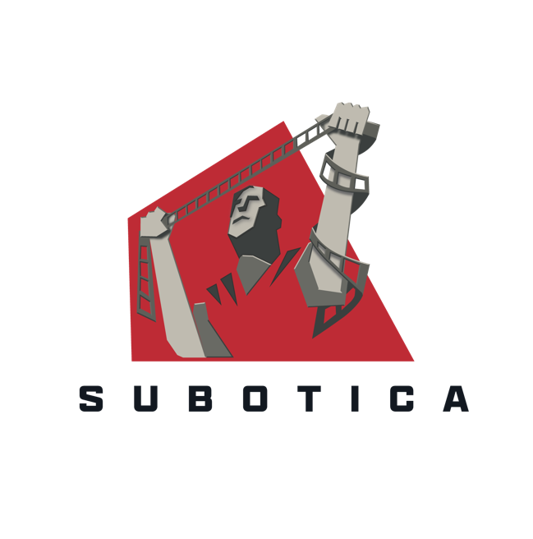

JOYRIDE

Section 481 Skills Plan Case Study

Introduction
Joyride is a feel-good road trip film produced by Subotica that shot in Kerry in July 2021. It follows the story of Joy, a headstrong solicitor, whose plan to offload her unwanted baby is derailed when a vulnerable but opinionated teenager steals their taxi.

Joyride was a regional S481 production. Its skills plan included six trainees and two new entrants that were local to the region as well as an internship program with the TV broadcasting course from Kerry College, Monavalley.

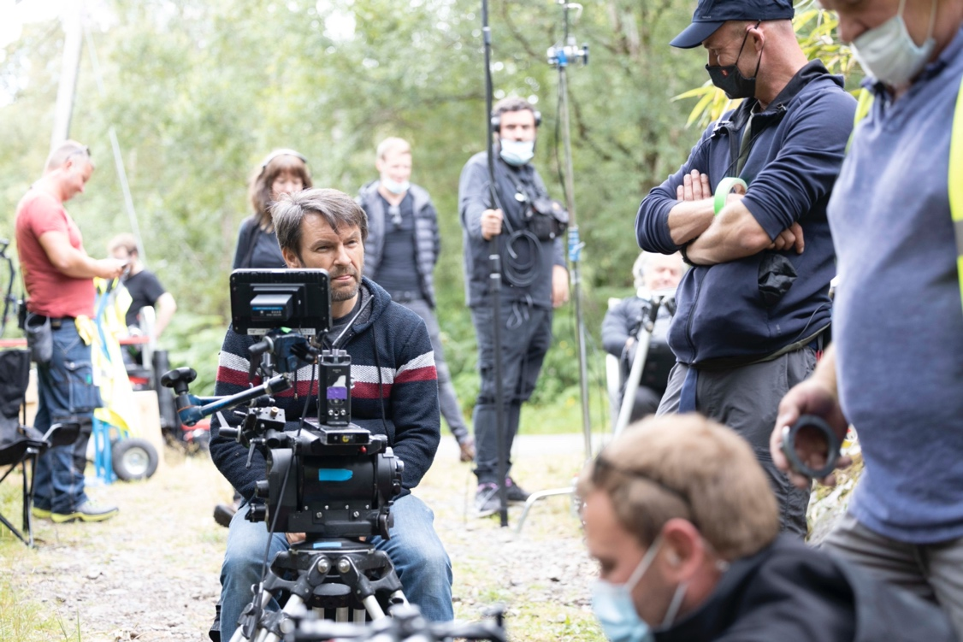
Photo by Malcom McGettigan

Skills Needs Identified

The cost of shooting outside of established regions is not to be underestimated. Being in the region put pressure on the budget for the film, largely related to travel and accommodation for crew and cast. It made sense for us to try and find as many local crew as possible. However this proved challenging due to the fact that the crew base in Kerry isn’t yet as established as other regions such as Dublin, Galway or Limerick.
Siobhan O’Sullivan from Screen Kerry has compiled an extensive database of people in the region with previous film or television experience, and through her network we were able to find great crew.

“As we were shooting in the Kerry region we made it our mission to hire as many crew as was possible who reside in that area. We did a mailshot ad in conjunction with Screen Kerry which we had a good response to. We were able to hire several crew members through that.” - Skills Development Co-ordinator Elaine Nicell

The individual learning objectives were put together early on in production by a collaboration of the skills participant and their mentor in discussing the mentors’ requirements for that particular department and how the skills participant could perform the relevant tasks and have more knowledge and experience by the end of the shoot with a possibility of moving up to a higher position.

“I always had a passion for film. I was in my 3rd year studying TV and Film during the filming of “Joyride” and had not got to opportunity to work in the industry before it. It was all very new territory for me.” – Production Trainee, Alan O’Mahony

Joyride’s skills plan included an internship program for the students of the Broadcast Production Skills course at Kerry College Monavalley Campus. Lead instructor, Brian Nolan, outlined the benefit for students on the course who worked on Joyride: "Real world experience on productions is critical. Kerry College Trainees got the chance to work on “Joyride” while still in a training environment. This was an opportunity to hone their skills and gain an industry credit as they start out on their Film/TV careers".

Skills Needs Addressed

The production has had a continued commitment to train the trainees and new entrants, to help with sustainable employment for the industry.
Production Trainee Alan described his role on the production: “I was able to see all aspects of the production. On a daily basis, I went from the Production Office to Unit Base and Set. I sourced and gathered important items and delivered them to the correct person. If anyone in the crew wanted something from an outside location, I would be the person to get it.”

Art Department intern Hannah also offered a perspective on her role on the production: “I think the unique aspect my role brought to this project was helping the film come to life. I worked in the Art Department with the designer and Art Director and they were able to show me what it takes to make a film look "realistic". I remember one of the girls saying "It's really hard to mimic real life".

Through individual feedback from both the mentors and HODs the production ran well as the trainees were continually learning and improving on the job which contributed to an all-round good collaboration and production.

The camera and accounts department found sourcing experienced crew/mentors was a huge challenge due to the large amount of productions shooting simultaneously last summer.

Trainees needed to be nominated as skills participants from within a 45km radius of the production base, which often resulted in the hiring of inexperienced new entrants.

For example, the camera trainees were unfamiliar with the equipment and the terminology being used and as a result had greater learning needs.

While it is important to take on local new entrants in order to establish local crew bases it is just as important to note that quality training can only happen when the team as a whole is experienced enough to support training, particularly on a fast moving shoot such as “Joyride”.

Progression of Talent Development

Upon completion of their skills plans many of the trainees shared that they felt more confident to ask questions about any new skills they were working on as both they and their mentors were aware that these learning tasks would be tracked during the process so as the participants could finish the job having performed all or most of the learning objectives highlighted at the beginning.

Most trainees completed the production with a good knowledge of the workings of their department and the individual tasks expected of them so they can move on to their next one with more experience and confidence whether it will be with their current HOD or a new one. Most of the participants moved straight on to a new job when the shoot was completed.

Production trainee Alan got a job working as a trainee AD on a feature film and a high budget TV series. He then went back to finishing his degree in college in Tralee and hopes to work again in the industry: “I am currently just finishing up my degree in TV and Film. ‘Joyride’ cemented to me that I want to work in the TV and Film Industry. I will pursue other jobs in the industry next.”

Art department Intern Hannah went on to be hired in a full time position on a TV series shot in Galway and plans on gaining more experience in the art department: “I'm hoping to keep pushing with film work and to explore different areas of the Art and Props Department.”

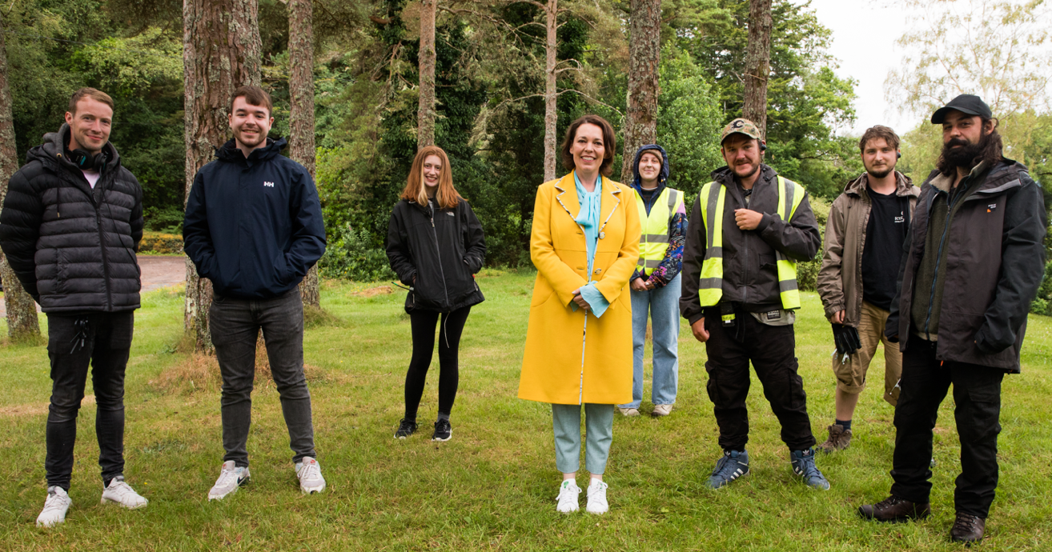
Photo by Tara Donoghue

Sustainable Production

Due to it being the first regional production produced by Subotica ‘Joyride’ was unfortunately unable to enact a full carbon action plan. However the production was still able to utilise Albert’s carbon footprint calculator to capture the production’s environmental impact which provided valuable data. With it being a regional road trip film the largest contributor to our carbon footprint came from travel and accommodation.

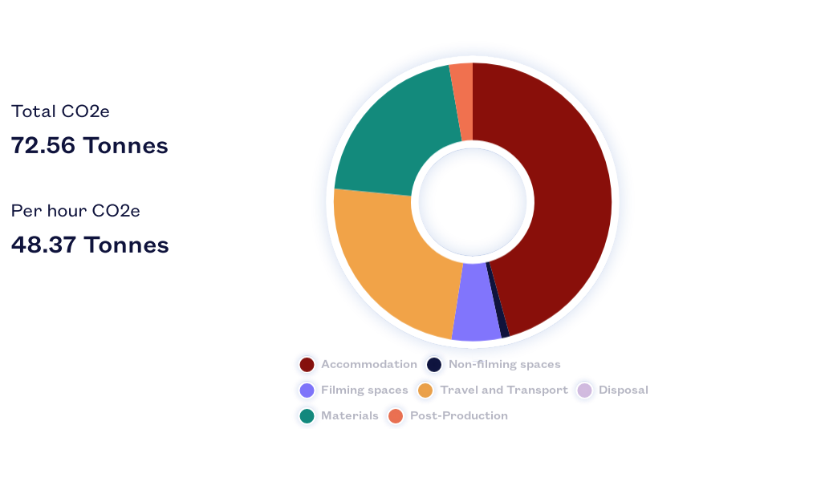

“Now having familiarised ourselves with the region and developed relationships with local suppliers we are confident that we would be able to implement an effective carbon action plan on future productions based in Kerry and obtain the full Albert certification.” - Production Exec. Jamie Colclough

Impacts & Outcomes

Overall Joyride’s skills plan had a positive effect not only for the production and the trainees but also for developing the regional film industry.

Siobhan O'Sullivan. Kerry ETB Film Development Officer, highlighted the benefit to having Joyride film in the county: "As we grow the depth of the crew base in Kerry, productions like ‘Joyride’ provide employment to crew and trainees based locally, enabling them to further their skillset & gain career experience. This is highly beneficial to the regional industry."

In terms of training and development in the region, the need is huge and the production did as much as possible to address it by creating opportunities for people at all levels, people new to the industry with transferrable skills, people with no experience and students who hadn’t had the opportunity to do the usual project work due to COVID restrictions.

Speaking about the experience of filming in Kerry, Producer Aoife O’Sullivan commented:

“Kerry is the heart of the film. It’s where it’s set, it’s where the writer is from, it’s what she writes about, all those locations that appear in the film are important to the visual story, so we really wanted to shoot it there. Local incentives and the regional tax credit made this possible – without them there’s no doubt that we would have been based in the Dublin/Wicklow region for budgetary reasons. Kerry is absolutely gorgeous and it comes across on screen. It's underrepresented in Irish film – along with a lot of other regional locations around Ireland. Hopefully with the help of the regional tax credit and the upskilling of regional crews this will change over time.”

The trainee skills plans and quality assurance report were compiled by Skill Co-ordinator Elaine Nicell and the case study was compiled by Production Exec. Jamie Colclough

